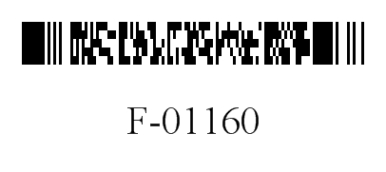
DEPARTMENT OF HEALTH SERVICES STATE OF WISCONSIN
Division of Medicaid Services DHS 107.06(3)(c), Wis. Admin. Code
F-01160 (06/2013)

FORWARDHEALTH

ACKNOWLEDGMENT OF RECEIPT OF HYSTERECTOMY INFORMATION

Instructions: Print or type clearly. Before completing this form, refer to the Acknowledgement of Receipt of Hysterectomy Information Completion Instructions, F-01160A.

Name — Member |  | Member Identification Number
Address — Member

Name — Physician |  | National Provider Identifier
It has been explained to |  |  | (me) that the hysterectomy to be
 | (Name — Member)

performed on her (me) will render her (me) permanently incapable of reproducing.

SIGNATURES — Member, Representative, and Interpreter
Member |  | Date Signed
Representative |  | Date Signed
Interpreter |  | Date Signed

